Concepcion, Johnmar Gabriel Q.

CPE 028 – CPE41S1

**Final Case Study**

**Network Automation and Programmability Using Ansible**

**Objectives**

**Part 1: Add the DEVASC and Ubuntu VM to GNS3**

**Part 2: Build the network topology in GNS3**

**Part 3: Checking required installations on Ubuntu VM**

**Part 4: Configure SSH on the devices**

**Part 5: Get started on Ansible**

**Part 6: Running the yaml files.**

**Background/Scenario**

In this lab, you will be utilizing Ansible to setup the Apache web server, EIGRP, and ACLs through the use of network automation and programmability.

**Required Resources**

**Hardware**

* A computer with GNS3 and VirtualBox installed and is capable of running multiple VMs at the same time. (4 CPU Cores or more, 8GB ram or higher)

**Software**

* GNS3
* VirtualBox with installed:
  + DEVASC VM
  + Ubuntu desktop LTS VM (Apache2, SSH, Ansible)

**Part 1: Add the DEVASC and Ubuntu VM to GNS3**

**Step 1: Add DEVASC VM to GNS3**

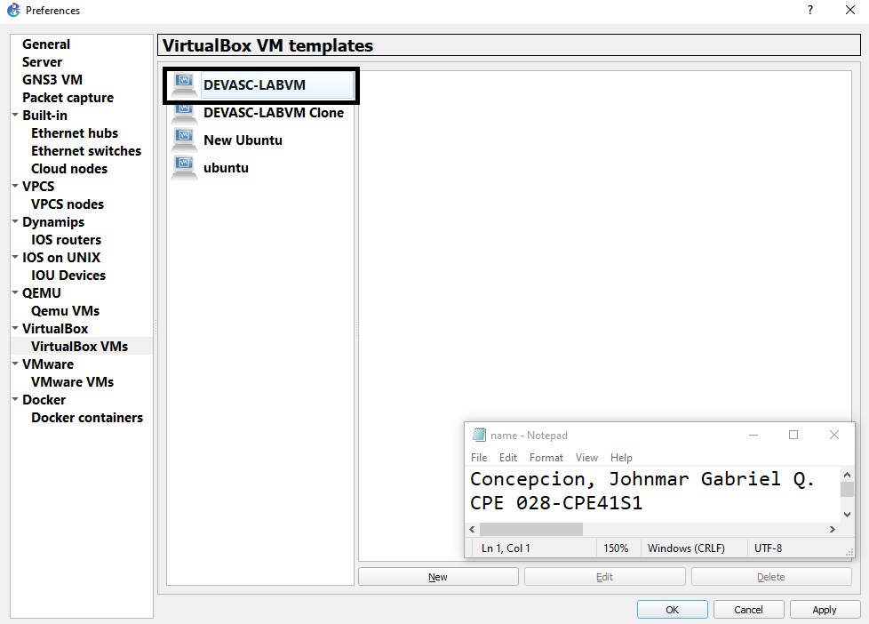

**Step 2: Add Ubuntu VM to GNS3**

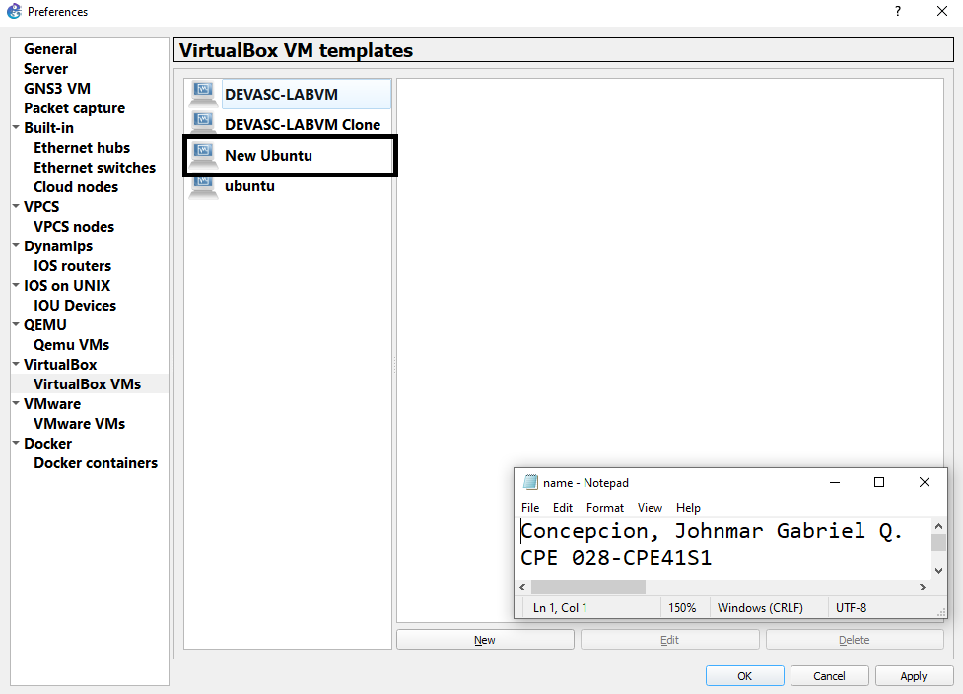

**Part 2: Build the network topology in GNS3**

**Step 1: Drag the required components inside GNS3 and connect them to the specified interface.**

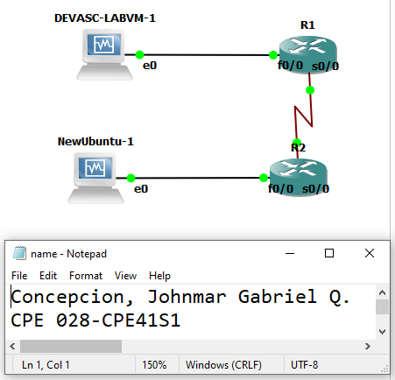

**Step 2: Run all nodes on GNS3**

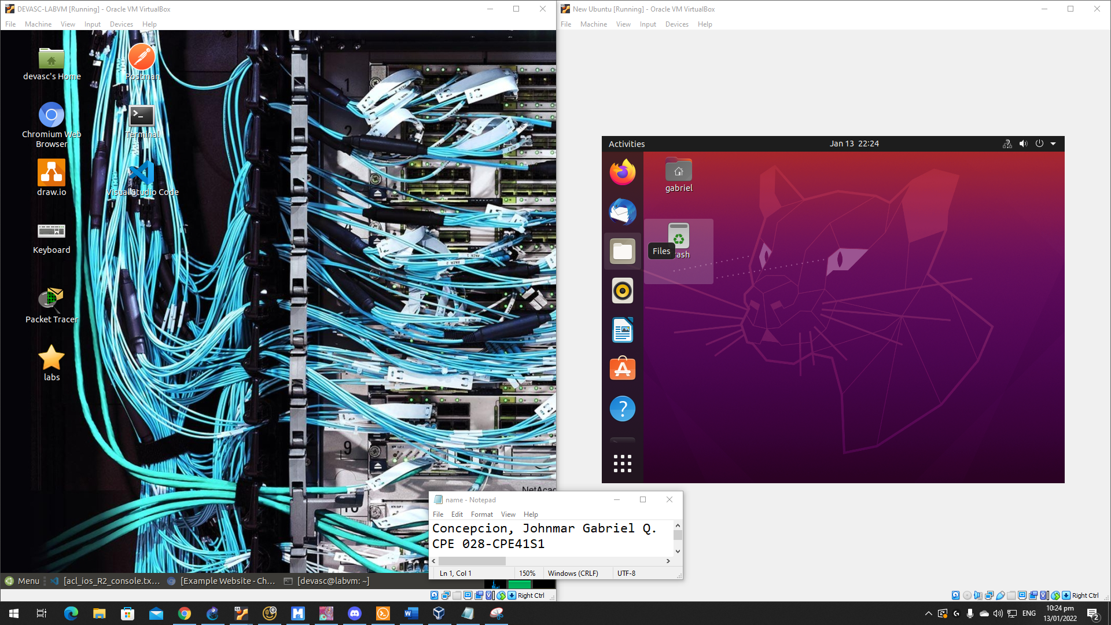

**Step 3: Configure the interfaces according to the table below**

|  |  |  |  |
| --- | --- | --- | --- |
| **Components** | **Interface** | **IP Address** | **Subnet Mask** |
| **DEVASC-LABVM-1** | **e0** | **192.168.10.2** | **255.255.255.0** |
| **NewUbuntu-1** | **e0** | **192.168.20.2** | **255.255.255.0** |
| **R1** | **f0/0** | **192.168.10.1** | **255.255.255.0** |
| **s0/0** | **10.10.10.1** | **255.255.255.252** |
| **R2** | **f0/0** | **192.168.20.1** | **255.255.255.0** |
| **s0/0** | **10.10.10.2** | **255.255.255.252** |

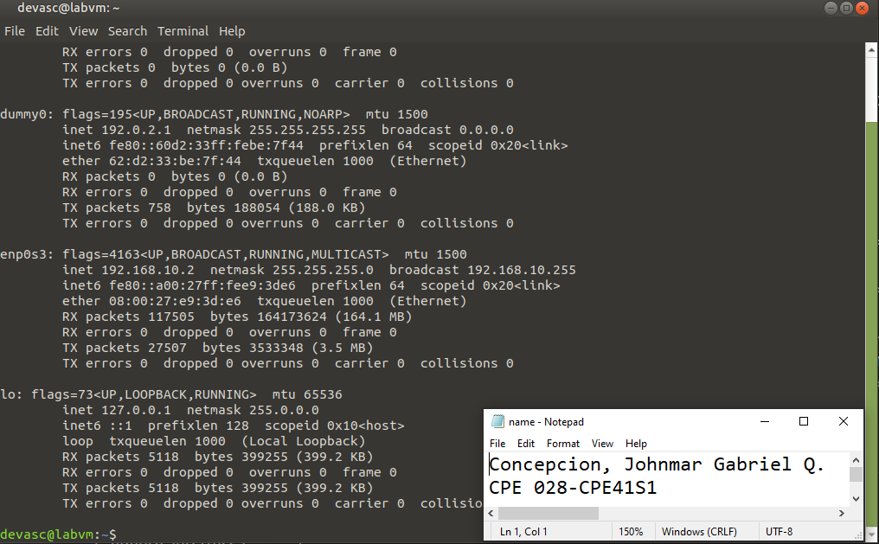

**DEVASC VM Configuration**

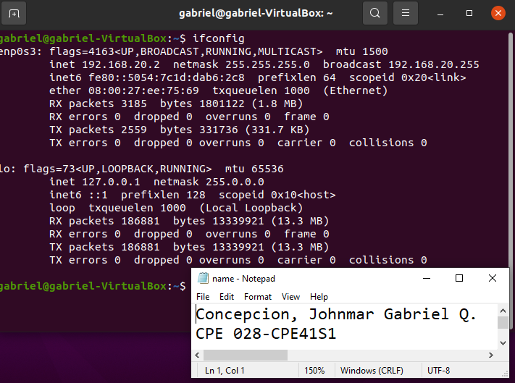

**Ubuntu VM Configuration**

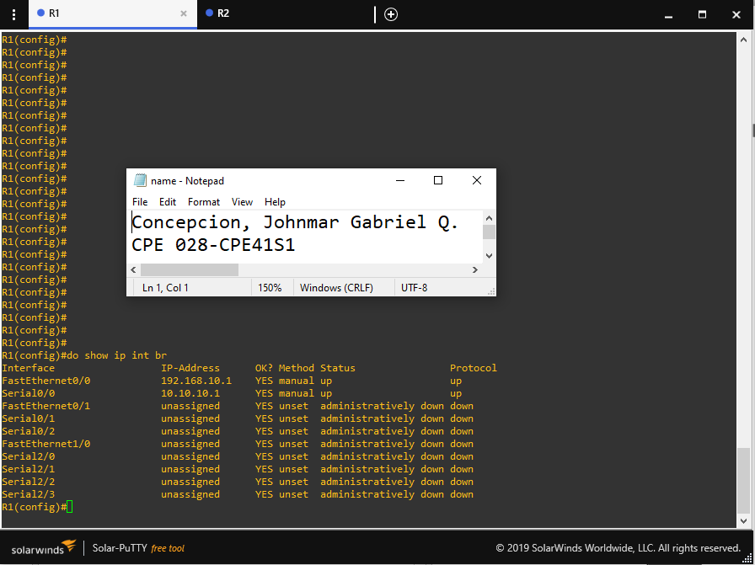

**R1 Interface Configurations**

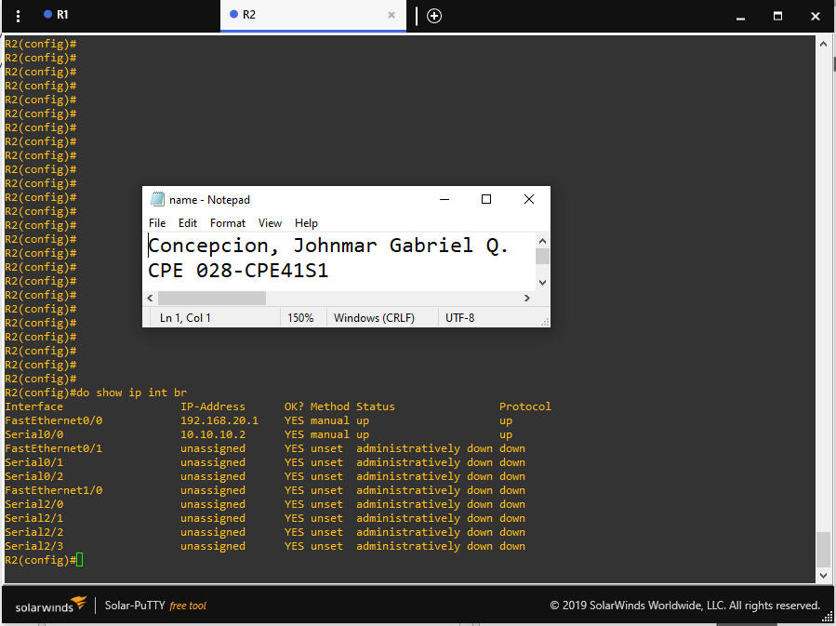

**R2 Interface Configurations**

**Part 3: Checking required installations on Ubuntu VM**

**Step 1: Start and check Apache2 status**

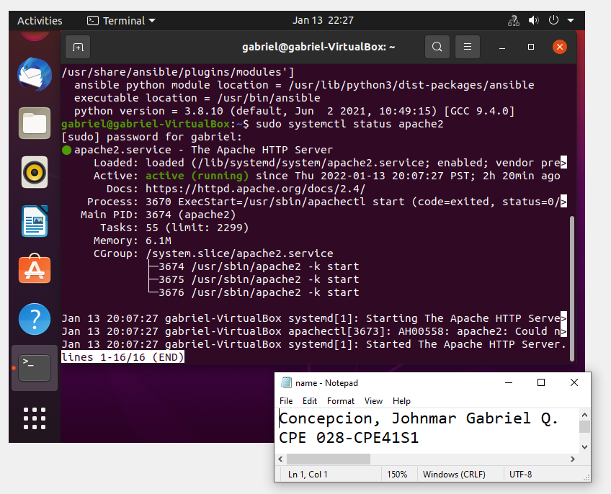

**Step 2: Start and check SSH status**

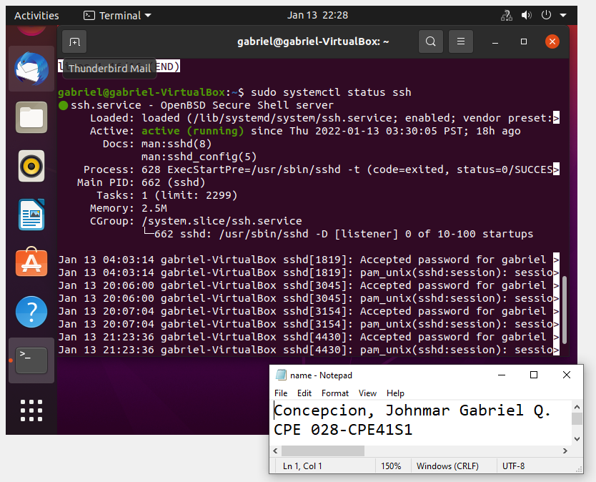

**Step 3: Install and check Ansible**

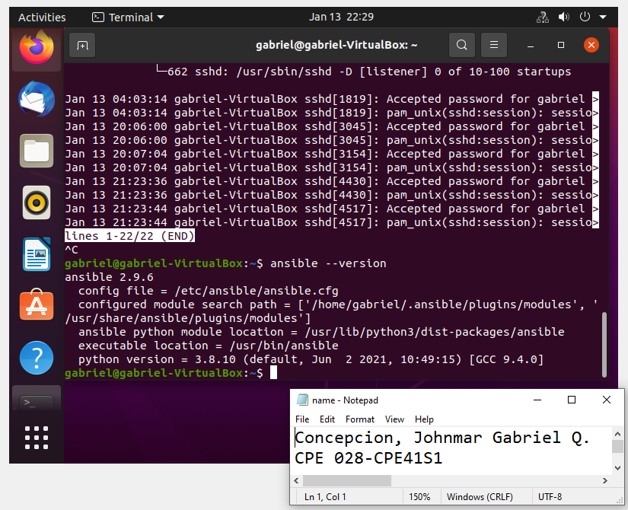

**Part 4: Configure SSH on the devices**

**Step 1: Configure SSH on DEVASC VM**

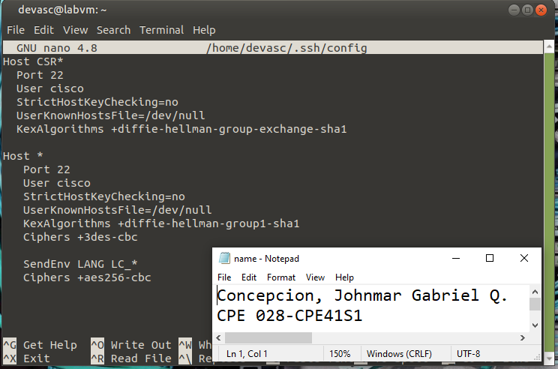

**Step 2: Configure SSH on Ubuntu VM**

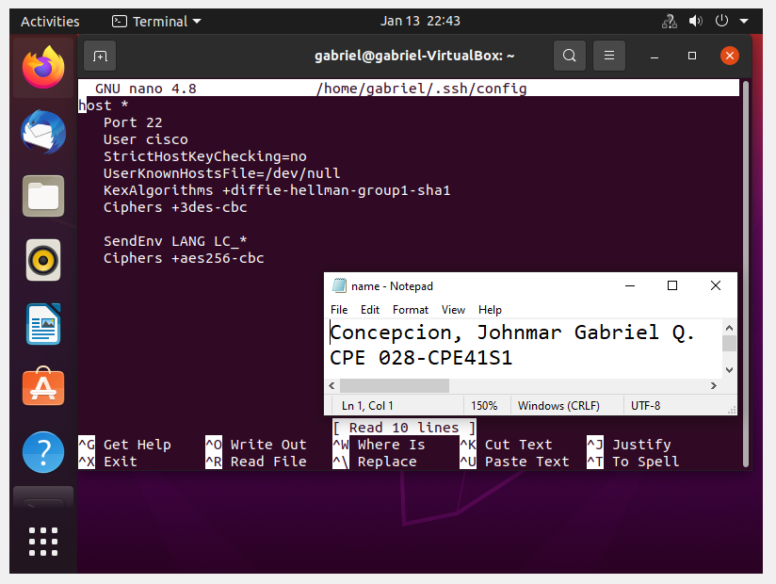

**Step 3: Configure SSH on R1**

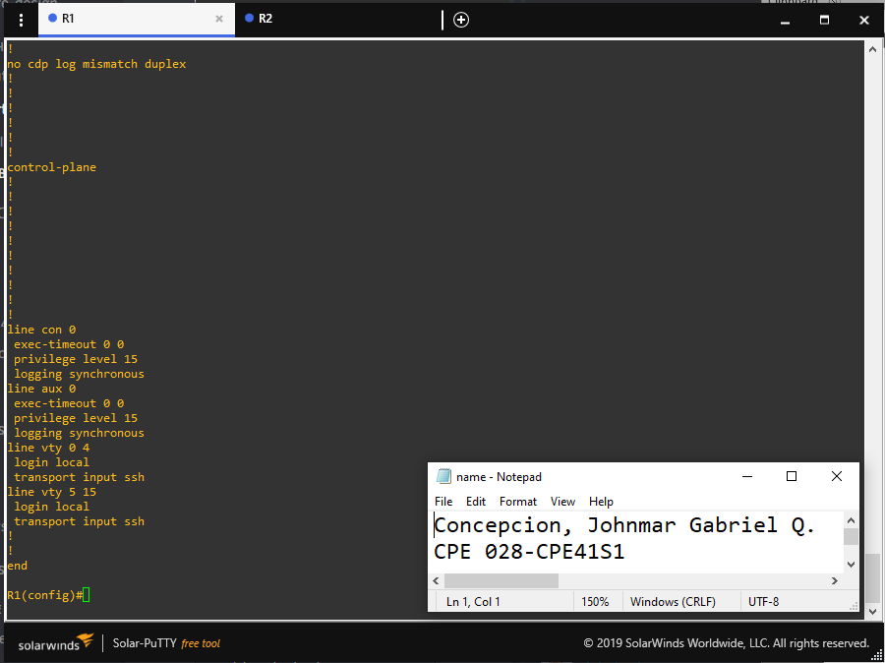

**Step 4: Configure SSH on R2**

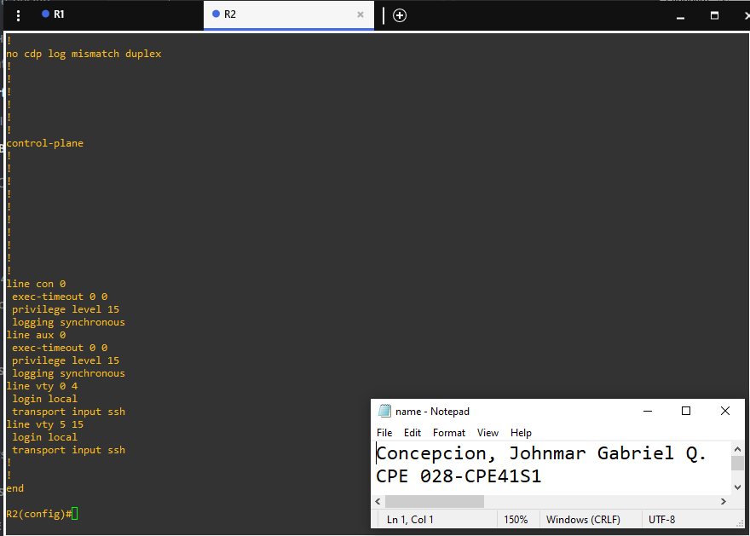

**Part 5: Get started on Ansible**

Create a folder named <last name>_FinalCaseStudy then open VS Code and open the created folder.

**Step 1: Create the hosts file**

Inside the <last name>_FinalCaseStudy folder, create a file named hosts and paste the following code inside.

[routers]

R1 ansible_host=10.10.10.1

R2 ansible_host=10.10.10.2

[routers:vars]

ansible_user=cisco

ansible_password=cisco123

ansible_connection=network_cli

ansible_network_os=ios

ansible_port=22

ansible_become=yes

ansible_become_method=enable

ansible_become_pass=cisco123

[ubuntu]

192.168.20.2 ansible_ssh_pass=cisco123 ansible_ssh_user=gabriel ansible_password=cisco123 ansible_port=22 ansible_become=yes ansible_sudo_pass=cisco123

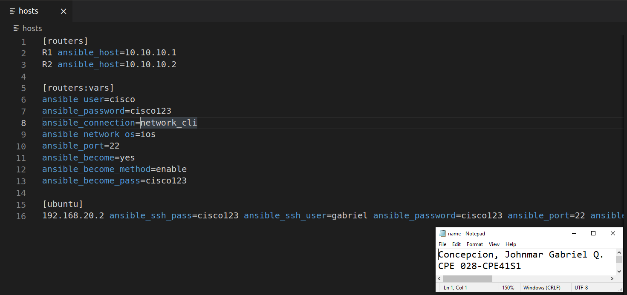

**Step 2: Create ansible.cfg file**

Inside the <last name>_FinalCaseStudy folder, create a file named ansible.cfg and paste the following code inside.

[defaults]

inventory = ./hosts

host_key_checking = false

timeout = 15

deprecation_warnings=False

remote_user = Gabriel

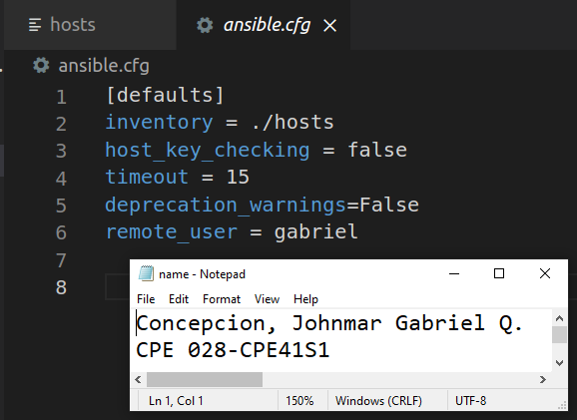

**Step 3: Create index.html file**

Inside the <last name>_FinalCaseStudy folder, create an html file named index with the use of the following code:

<title>Example Website</title>

<body>

<h1>Concepcion, Johnmar Gabriel Q. - Final Case Study</h1>

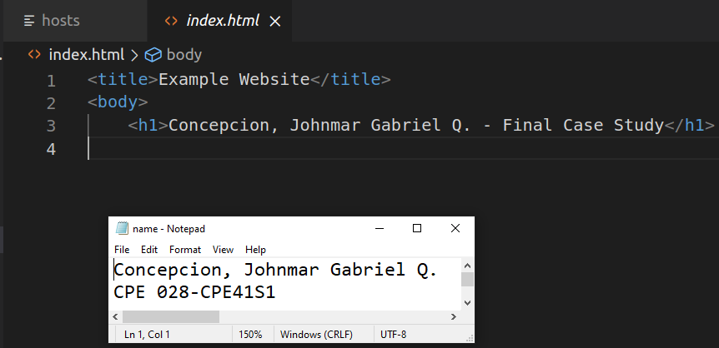

**Step 4: Create apache.yaml file**

Create the yaml file for the Apache server. Create apache.yaml and paste the following code

---

- name: Installing Apache2 Server and Updating the Firewall

hosts: ubuntu

tasks:

- name: Installing Apache

apt:

name: apache2

state: present

- name: Starting apache2 service

service:

name: apache2

state: started

enabled: yes

- name: Allowing access to TCP Port 80

ufw:

rule: allow

port: '80'

proto: tcp

- name: Enabling firewall

ufw:

state: enabled

- name: Creating the website

hosts: ubuntu

tasks:

- name: Creating HTML test file

copy:

src: ./index.html

dest: /var/www/html/index.html

owner: root

group: root

mode: '0644'

register: index

- name: Starting the web service

service:

name: apache2

state: restarted

enabled: yes

when: index.changed

- name: Allowing access to TCP Port 80

ufw:

rule: allow

port: '80'

proto: tcp

- name: Reloading ufw

ufw:

state: reloaded

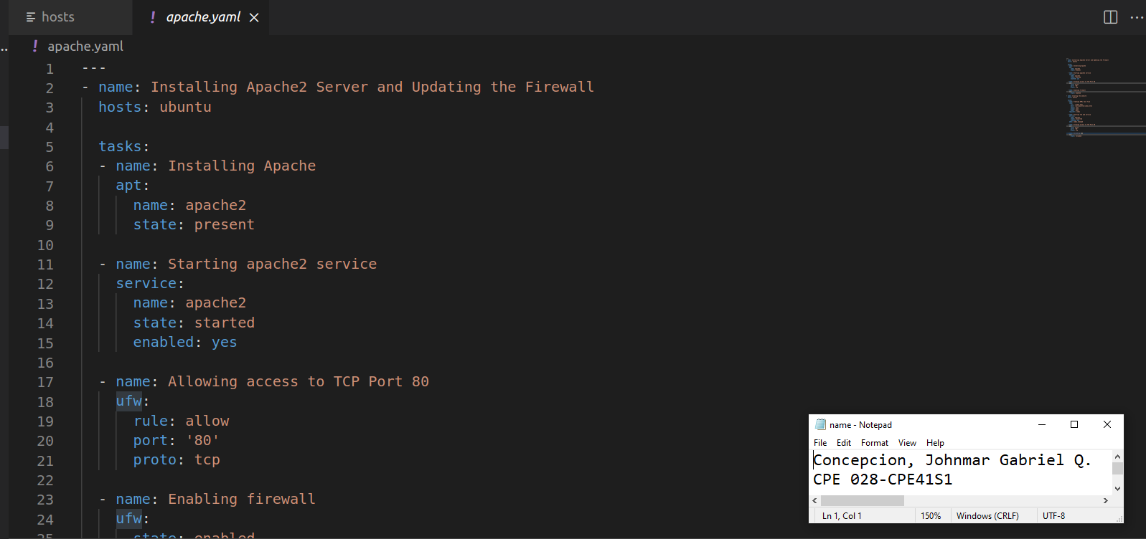

**Step 5: Create eigrp.yaml file**

Create the yaml file for configuring EIGRP on the two routers. Create eigrp.yaml and paste the following code

---

- name: Configuring EIGRP on Router 1

hosts: R1

gather_facts: false

connection: local

tasks:

- name: Adding an IP to host

ios_config:

lines:

- ip address 192.168.20.1 255.255.255.0

parents: interface F0/0

- name: Configuring EIGRP on Router 1

ios_config:

lines:

- network 10.10.10.2

parents: router eigrp 333

- name: Configuring EIGRP on Router 2

hosts: R2

gather_facts: false

connection: local

tasks:

- name: Adding an IP to host

ios_config:

lines:

- ip address 192.168.10.1 255.255.255.0

parents: interface F0/0

- name: Configuring EIGRP on Router 2

ios_config:

lines:

- network 10.10.10.1

parents: router eigrp 333

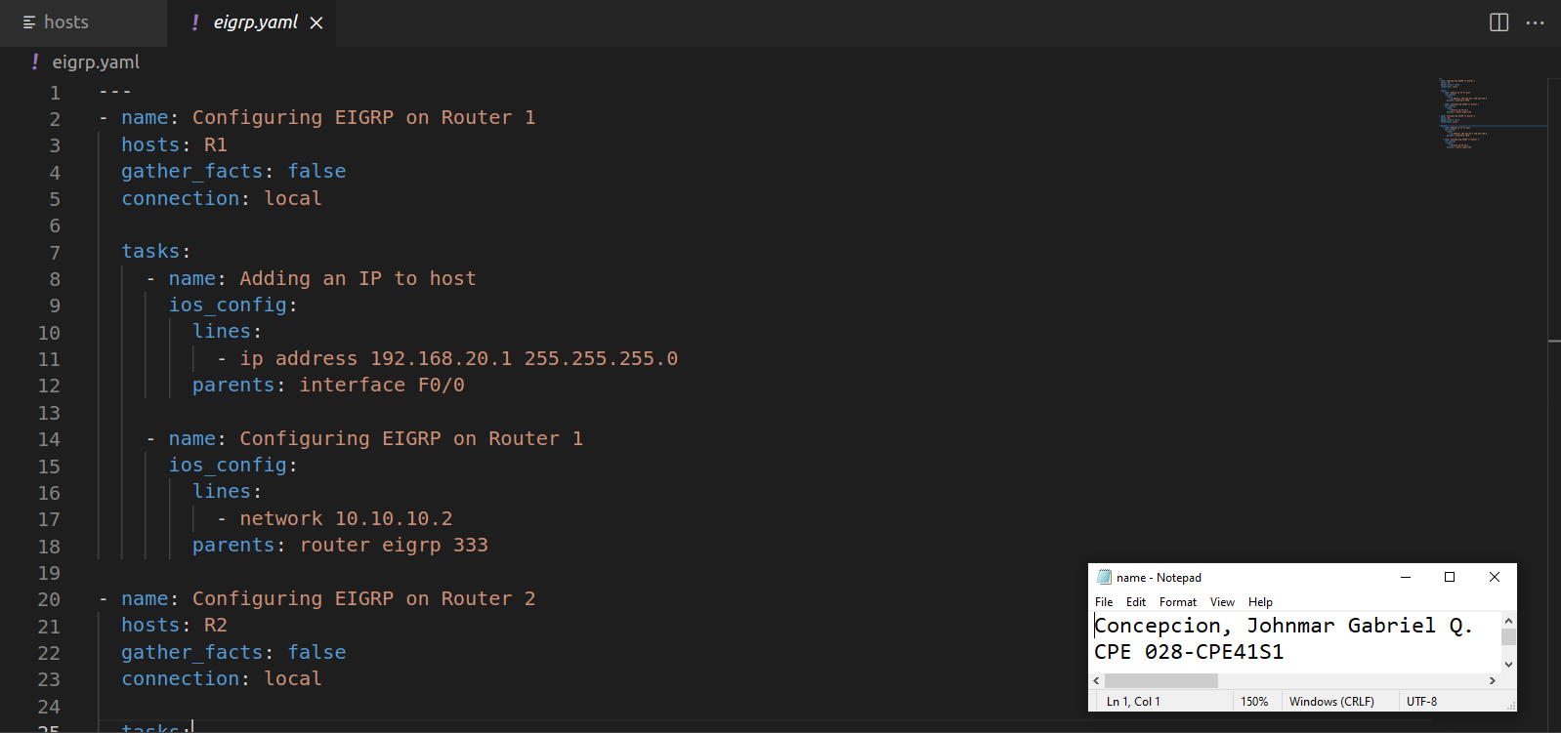

**Step 6: Create acl.yaml file**

Create the yaml file for configuring ACL on router 2. Create acl.yaml and paste the following code

---

- name: Configure ACL on Router 2

hosts: R2

gather_facts: false

connection: local

tasks:

- name: Configuring the ACL inbound

ios_config:

lines:

- ip access-group 110 in

parents: interface f0/0

- name: Creating the ACL rules

ios_config:

lines:

- access-list 110 deny icmp any any

- access-list 110 permit ip any any

before: no access-list 110

match: exact

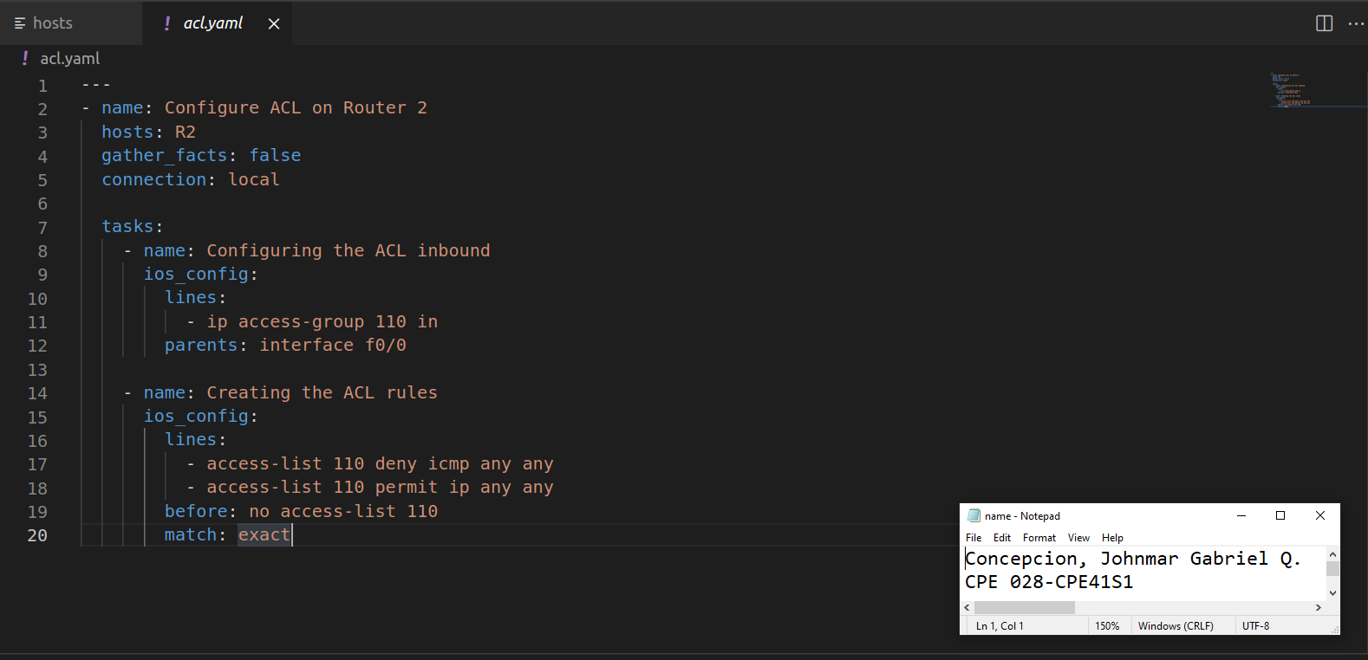

**Part 6: Running the yaml files.**

**Step 1: Run apache.yaml**

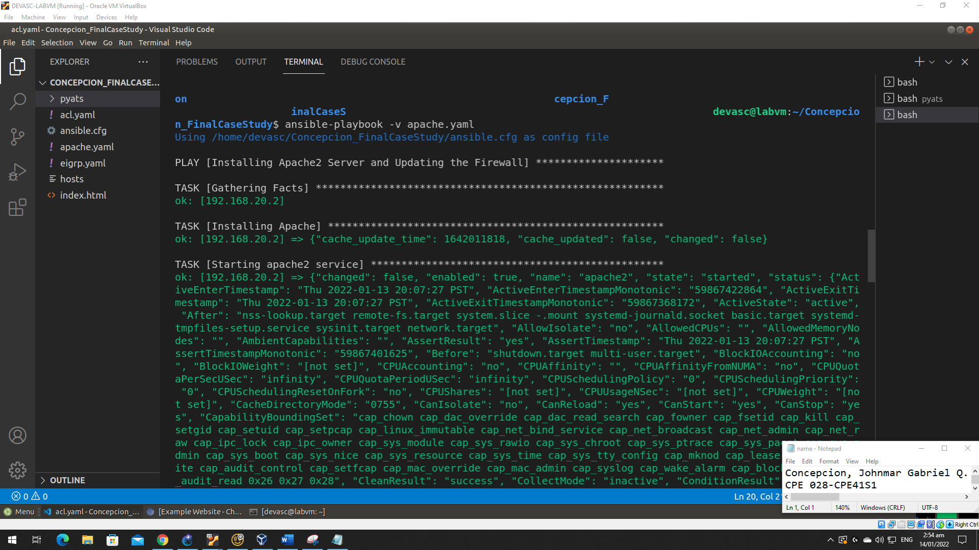

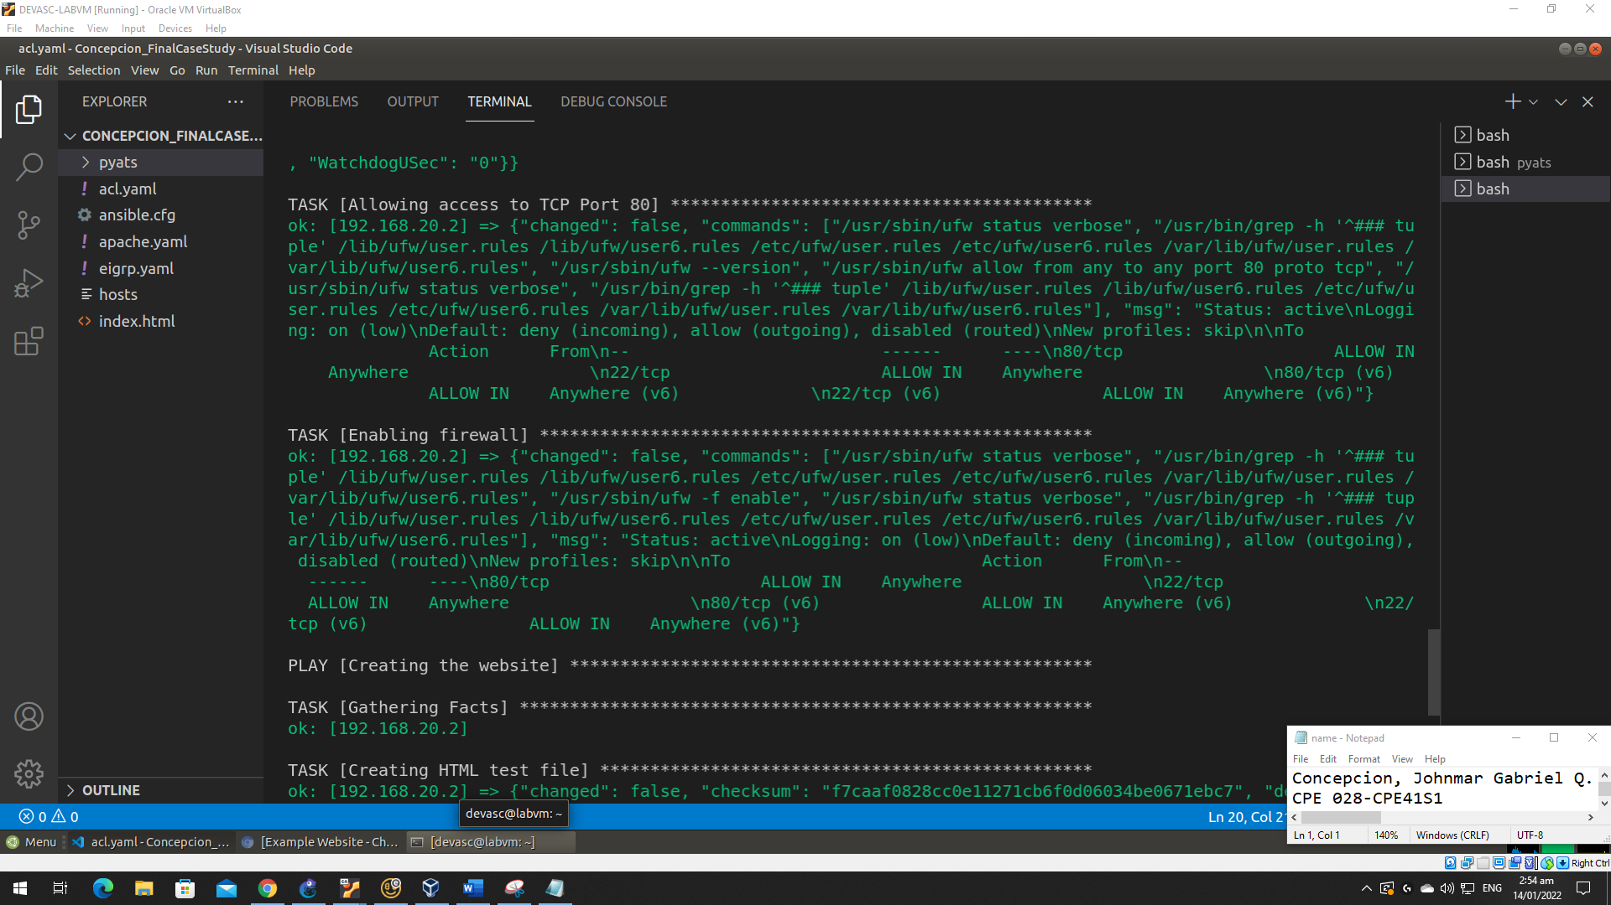

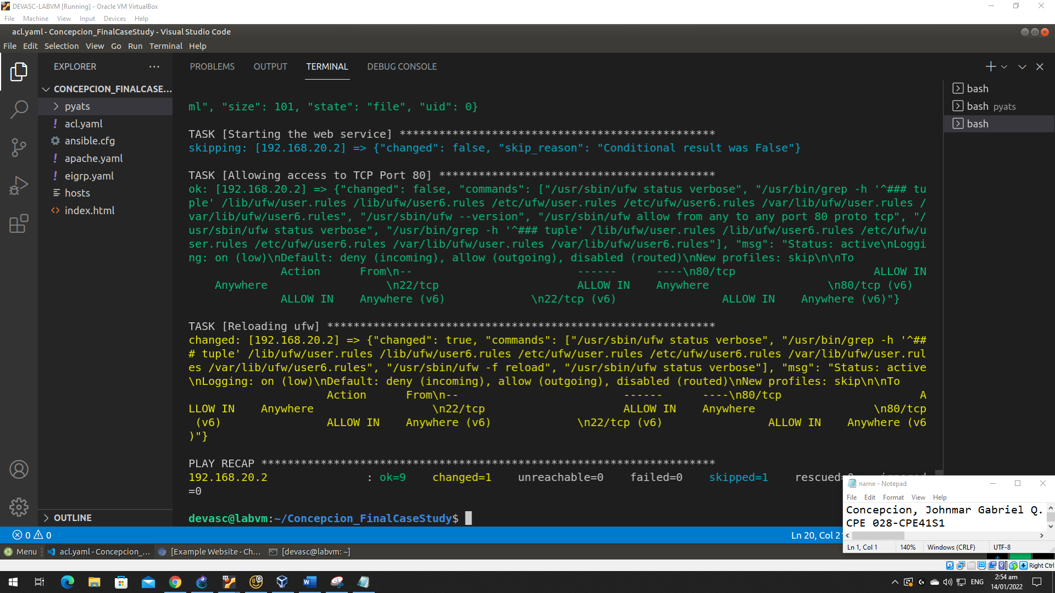

**Step 2: Run eigrp.yaml**

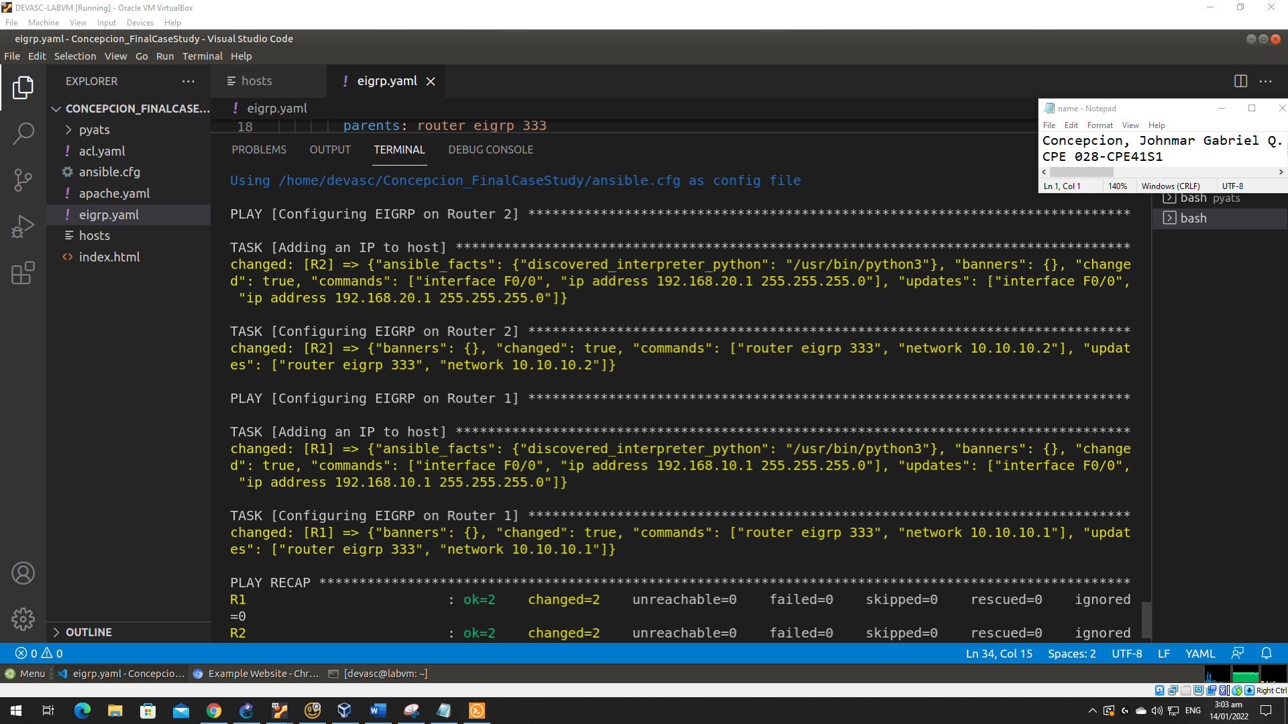

**Step 3: Run acl.yaml**

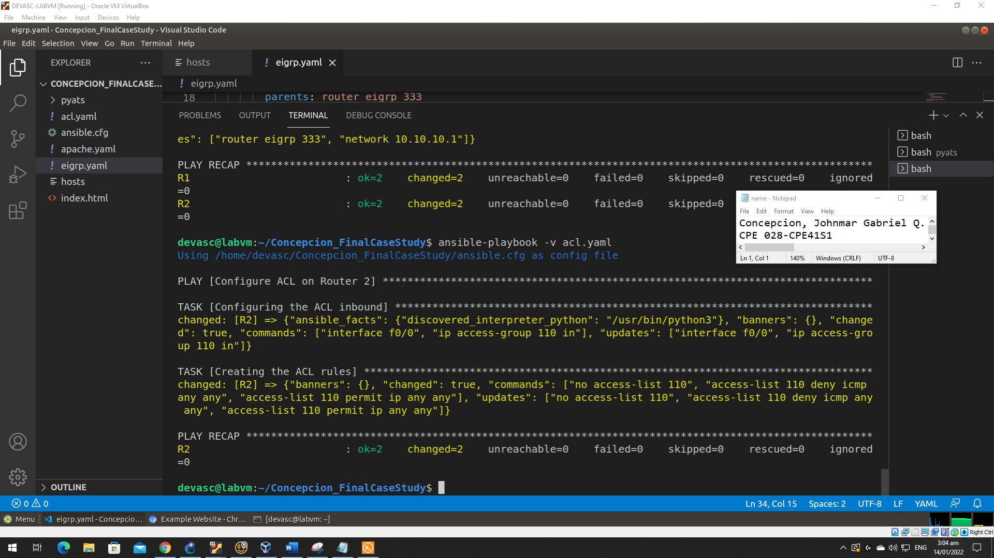

**Part 7: Using pyATS to test the network.**

**Step 1: Creating testbed for Ubuntu**

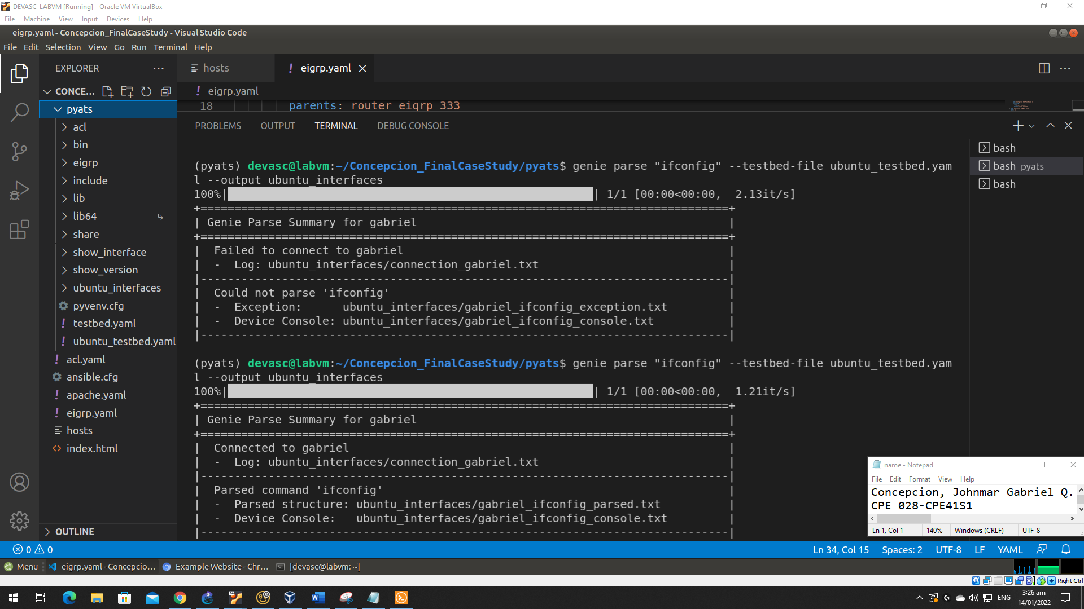

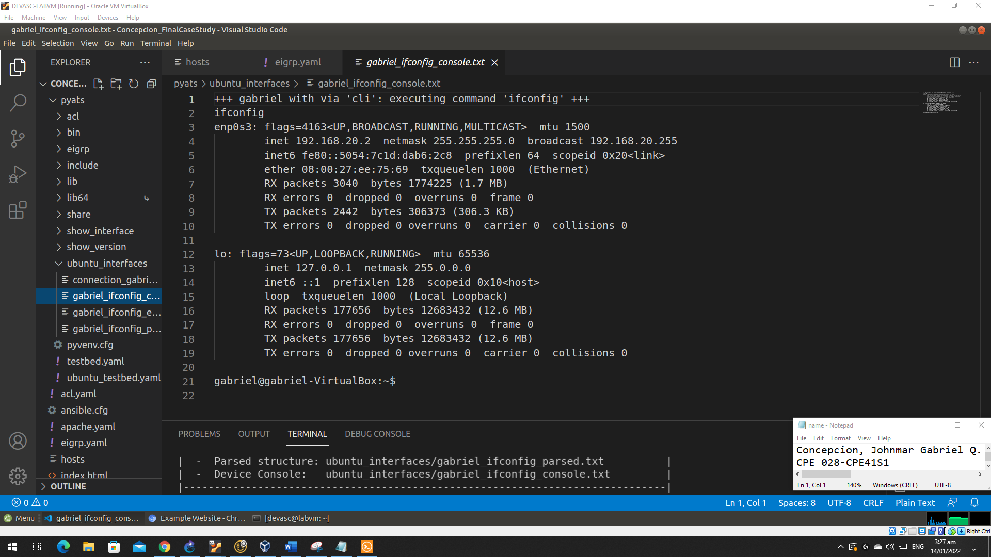

**Step 2: Creating testbed for EIGRP**

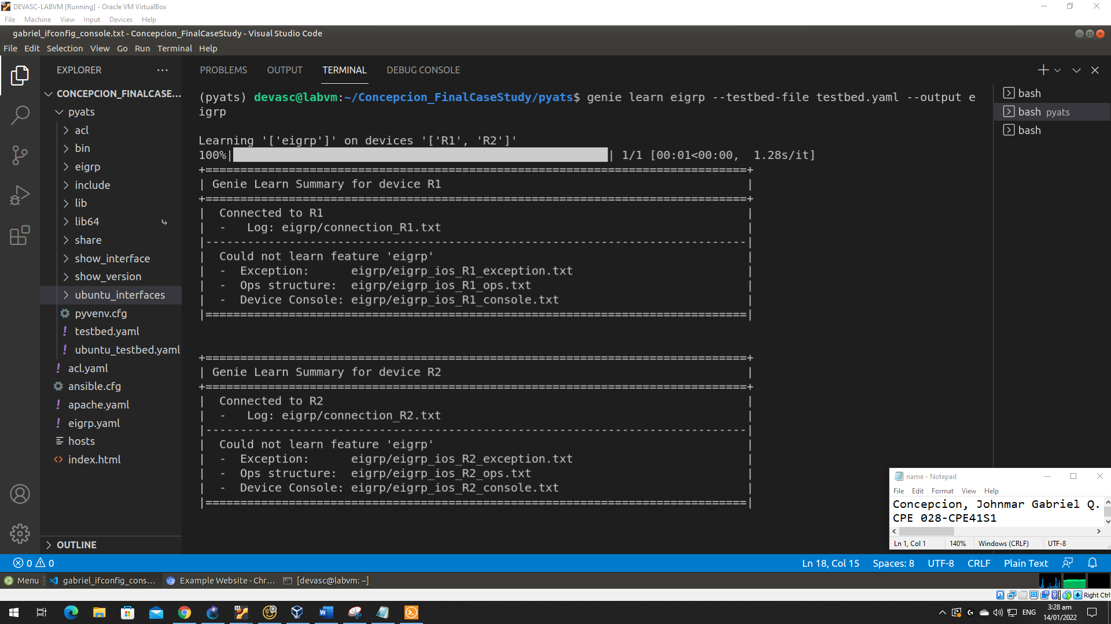

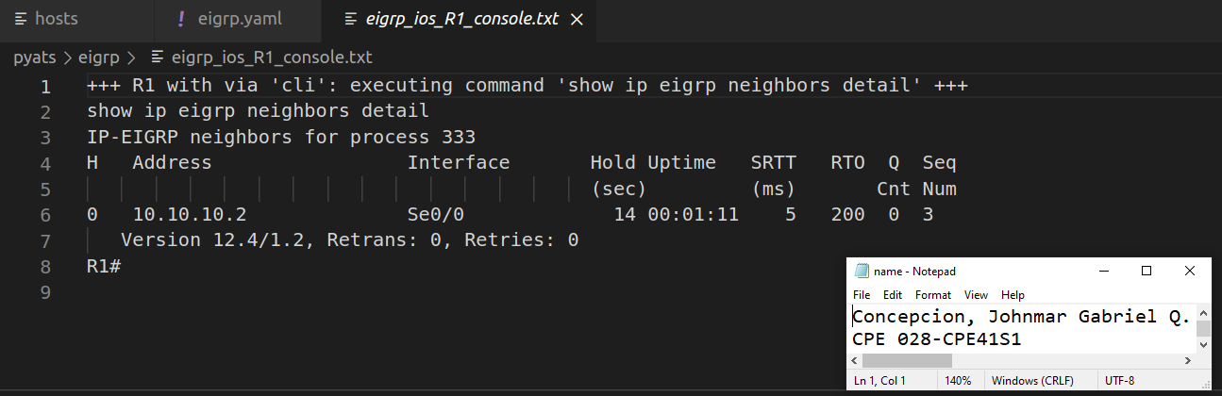

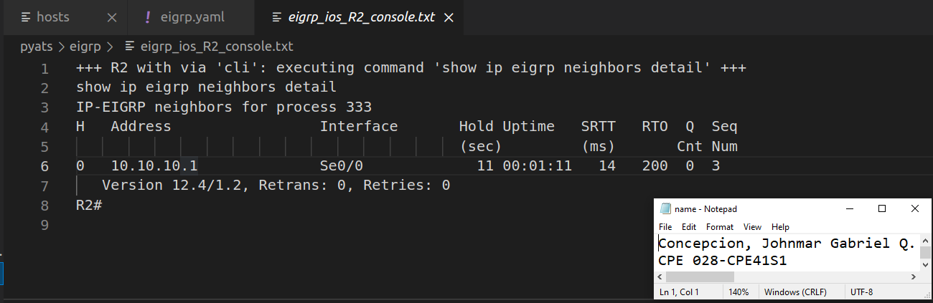

**Step 3: Creating testbed for ACLs**

